Ex1 :pointers

Output

1: a = 0061FEF4, b == 00B82F20, c = 00401AB0

2: a[0] = 200, a[1] = 101, a[2] = 102, a[3] = 103

3: a[0] = 200, a[1] = 300, a[2] = 301, a[3] = 302

4: a[0] = 200, a[1] = 400, a[2] = 301, a[3] = 302

5: a[0] = 200, a[1] = 128144, a[2] = 256, a[3] = 302

6: a = 0061FEF4, b = 0061FEF8, c = 0061FEF5

Explanation:

1- a = 0061FEF4, b = 00B82F20, c = 00401AB0

This output represents the locations that the pointers point to

a-> pointer to first element in array a

b-> pointer to 16 bytes allocated in memory

c-> simple pointer

locations->

a = 0061FEF4, b = 00B82F20, c = 00401AB0

content->

\*a = 1079922354, \*b = 12070776, \*c = 1077940385

garbage

2- a[0] = 200, a[1] = 101, a[2] = 102, a[3] = 103

This output represents the array a

C pointer points to the same location of a

For loop assigns values to array a

a[0]=101 , a[1]=102 ,a[3]=103

then c[0]=200 so a[0]=200

locations->

a = 0061FEF4, b = 00B82F20, c = 0061FEF4

content->

\*a = 200, \*b = 12070776, \*c = 200

3- a[0] = 200, a[1] = 300, a[2] = 301, a[3] = 302

This output represents the array a

 c[1] = 300; so a[1]=300

then

\*(c + 2) = 301;

This mean increment the pointer c location by 2 locations (2\*4 bytes(ineger size)) and put in it 301

So

C[2]=301 so a[2]=301

And then

    3[c] = 302;

This is equivalent to \*(c+3)=302

C[3]=302 so a[3]=302

locations->

a = 0061FEF4, b = 00B82F20, c = 0061FEF4

content->

\*a = 200, \*b = 12070776, \*c = 200

4-a[0] = 200, a[1] = 400, a[2] = 301, a[3] = 302

This output represents the array a

c = c + 1;

increment the pointer c location to the next location so it point to a[1]

    \*c = 400;

Then assign to it 400

C[0]=400 so a[1]=400

locations->

a = 0061FEF4, b = 00B82F20, c = 0061FEF8

content->

\*a = 200, \*b = 12070776, \*c = 400

5- a[0] = 200, a[1] = 128144, a[2] = 256, a[3] = 302

This output represents the array a

c = (int \*) ((char \*) c + 1);

cast the pointer c to char \* so when w increment it by one the location wil be

increased by 1 byte instead of 4 bytes and the casting the result to int\* so the pointer c will take the size of integer in the memory(4 bytes)

    \*c = 500;

The next page will explain !

locations->

a = 0061FEF4, b = 00B82F20, c = 0061FEF9

content->

\*a = 200, \*b = 12070776, \*c = 500

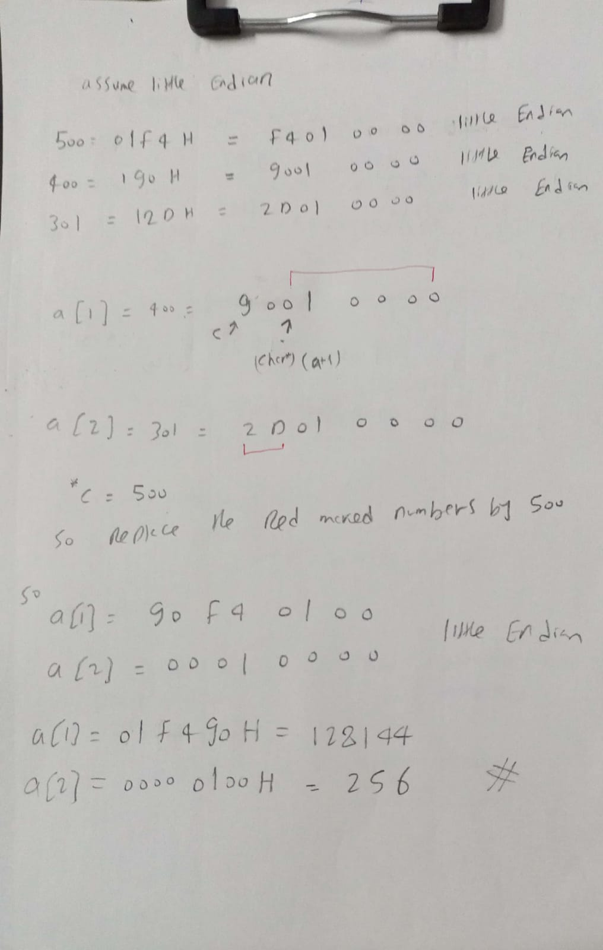

6- a = 0061FEF4, b = 0061FEF8, c = 0061FEF5

This output represents the locations that the pointers point to

 b = (int \*) a + 1;

a is of type int \* so when we increment it by 1 the location increases by

4 bytes

  c = (int \*) ((char \*) a + 1);

a is of type char\* so when we increment it by 1 the location increases by 1 byte

locations->

a = 0061FEF4, b = 0061FEF8, c = 0061FEF5

content->

\*a = 200, \*b = 128144, \*c = -1879048192